**Project Design Phase-II**

**Data Flow Diagram & User Stories**

|  |  |
| --- | --- |
| Date | 9 June 2025 |
| Team ID | LTVIP2025TMID59165 |
| Project Name | Citizen AI – Intelligent Citizen Engagement Platform |
| Maximum Marks | 4 Marks |

**Data Flow Diagrams:**

A Data Flow Diagram (DFD) is a traditional visual representation of the information flows within a system. A neat and clear DFD can depict the right amount of the system requirement graphically. It shows how data enters and leaves the system, what changes the information, and where data is stored.

**Example:** [**(Simplified)**](https://developer.ibm.com/patterns/visualize-unstructured-text/)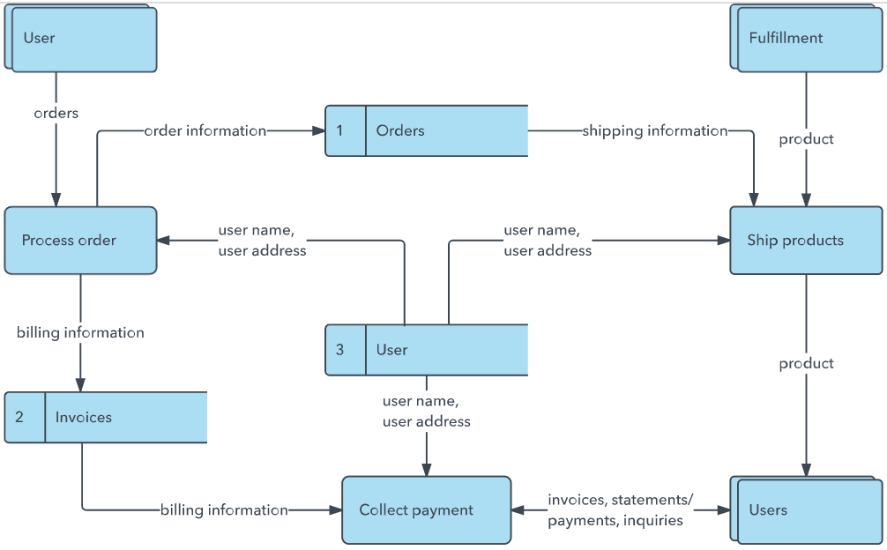

**User Stories**

Use the below template to list all the user stories for the product.

| **User Type** | **Functional Requirement (Epic)** | **User Story Number** | **User Story / Task** | **Acceptance criteria** | **Priority** | **Release** |
| --- | --- | --- | --- | --- | --- | --- |
| Customer (Mobile user) | Registration | USN-1 | As a user, I can register for the application by entering my email, password, and confirming my password. | I can access my account / dashboard | High | Sprint-1 |
|  |  | USN-2 | As a user, I will receive confirmation email once I have registered for the application | I can receive confirmation email & click confirm | High | Sprint-1 |
|  |  | USN-3 | As a user, I can register for the application through Facebook | I can register & access the dashboard with Facebook Login | Low | Sprint-2 |
|  |  | USN-4 | As a user, I can register for the application through Gmail | I can register & access the dashboard with Gmail Login | Medium | Sprint-1 |
|  | Login | USN-5 | As a user, I can log into the application by entering email & password | I can access the dashboard after login | High | Sprint-1 |
|  | Dashboard |  | As a user, I can view my dashboard after logging in | I can see my profile, settings & activities | High | Sprint-2 |
| Customer (Web user) | Registration / Login |  | As a user on the website, I can register and log in like mobile users | I can use all features on the web like mobile | Medium | Sprint-2 |
| Customer Care Executive | |  | | --- | |  |  |  | | --- | | Dashboard | |  | As a customer care agent, I can access the user data and assist them | I can see user info and solve their problems | Medium | |  | | --- | |  |  |  | | --- | | Sprint-3 | |
| Administrator | Dashboard / User Management |  | As an admin, I can manage users and monitor activities on the platform | I can update, delete or view user data | High | Sprint-3 |